1. Returns all lines containing “CSC 3”
   1. 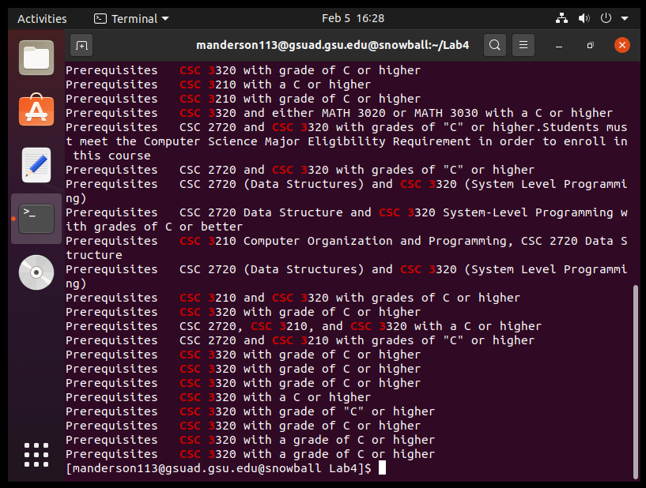
2. Returns all lines containing “CSC 3|CSC 1”
   1. N/A
3. Returns all lines containing “CSC 3” or “CSC 1”
   1. 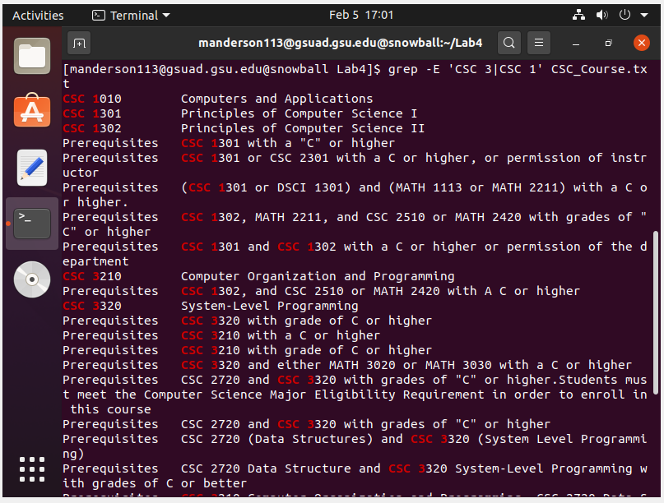
4. egrep is just grep -E, same result as above
   1. 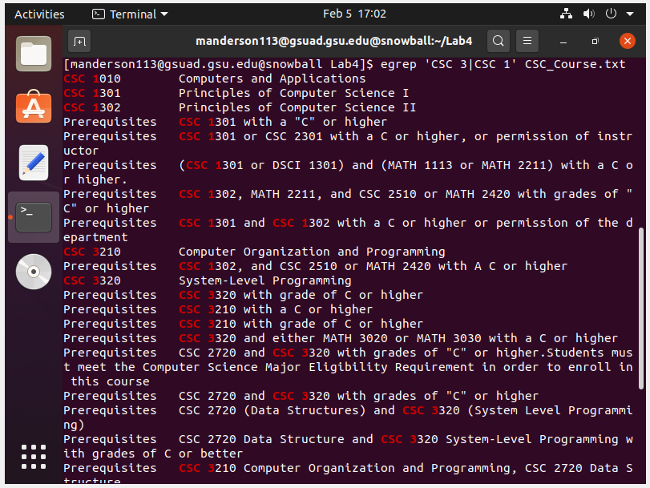
5. Returns all lines containing ‘3.000 Credit hours’
   1. N/A
6. Returns all lines equivalent to ‘3.000 Credit hours’
   1. N/A
7. Returns all lines that include ‘CSC’ and later ‘Programming’
   1. 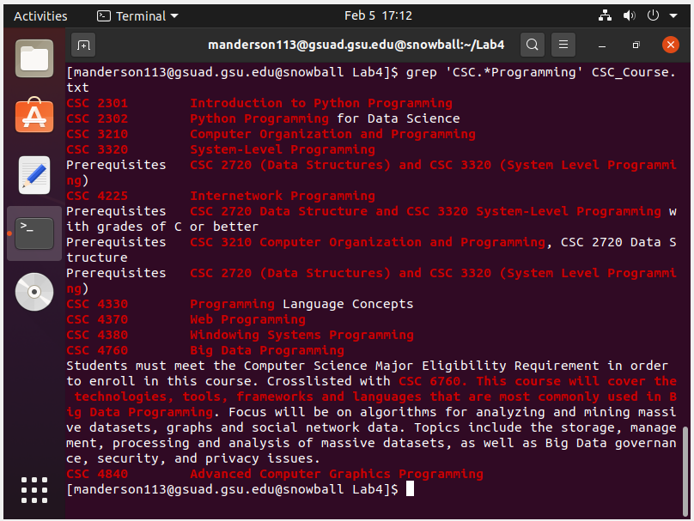
8. Returns all lines that include ‘CSC’ and end with ‘Programming’
   1. 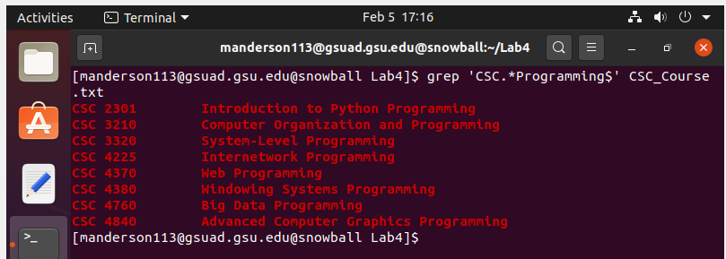
9. Returns all lines containing ‘CSC{2}’ followed by 0 or more characters other than ‘3’, followed by ‘{2}’
   1. N/A
10. Returns all lines that form full words containing ‘CSC’ followed by 0 or more characters other than ‘3’, followed by 2 ‘3’ characters, followed by 0 or more characters other than ‘3’
    1. 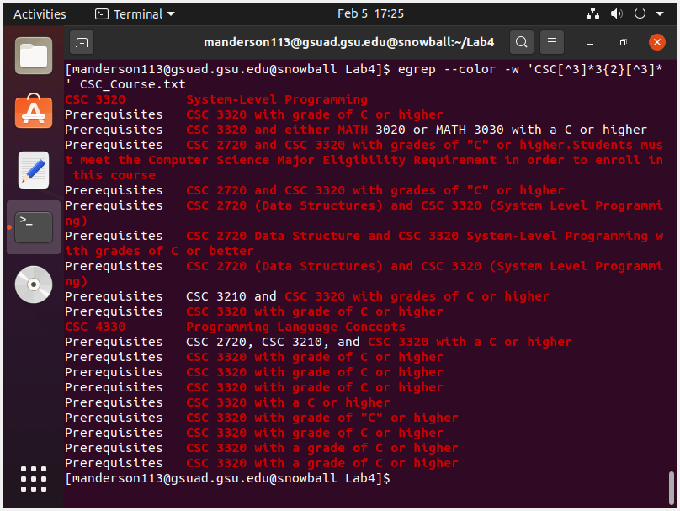
11. Returns all lines containing ‘CSC’, followed by 0 or more characters, followed by ‘++’
    1. N/A
    2. (C++ is not present in the file)
12. Same as above
    1. N/A
13. Returns all lines containing ‘CSC’, followed by 0 or more characters, followed by at least one ‘C’. The second ‘+’ makes the ‘+’ quantifier possessive, meaning all ‘C’s it matches cannot match to anything else.

**Optional Part:**

1. Uses extended regular expressions to only print each line containing ‘CSC 3’, followed by 3 digits, but without any trailing text of the line
   1. 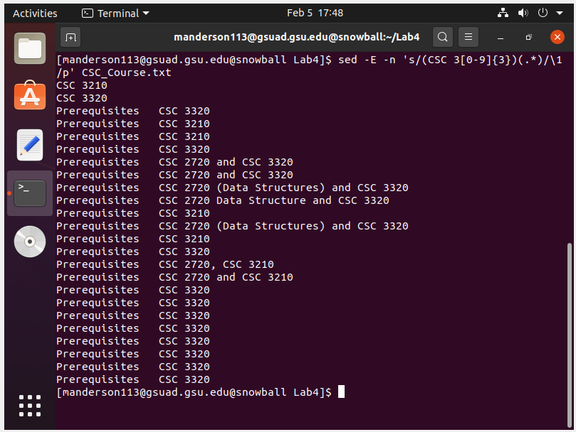
2. Prints all lines containing ‘CSC 3’ followed by three digits, followed by 0 or more characters, but only the section before the first ‘-’
   1. 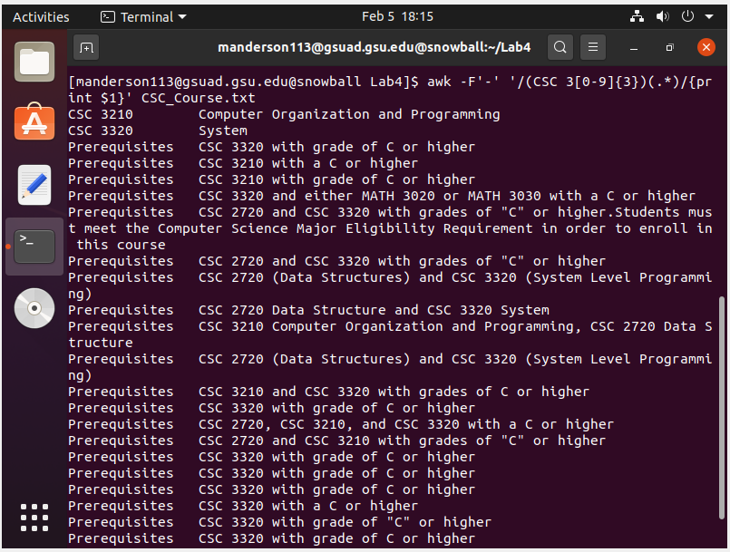
3. Prints all lines containing this expression, but only what follows: ‘CSC #### - ’ where # is any digit. Unfortunately there is no result for this, so **N/A**. However, I created this to display each course name:  
   sed -E -n ‘s/(^CSC [0-9]{4})(/t+)(.*)/\1: \3/p
   1. 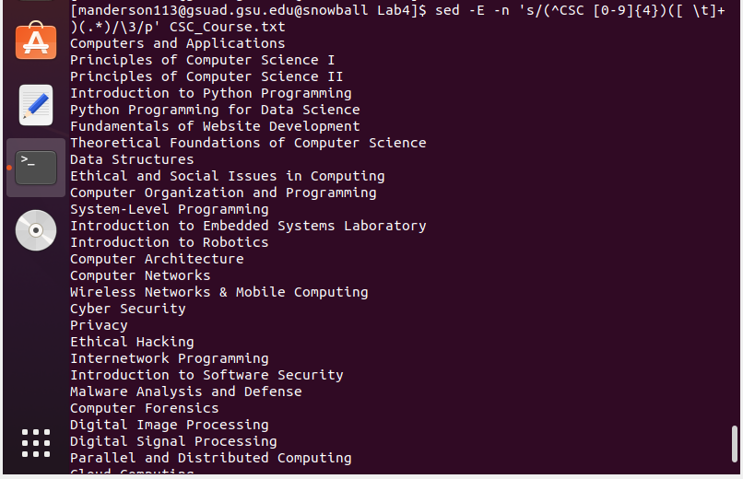
4. Same as above, but sorted alphabetically. Also unfortunately has no output, so **N/A**. However, I created this to display each course name, sorted:  
   sed -E -n ‘s/(^CSC [0-9]{4})(/t+)(.*)/\1: \3/p | sort
   1. 